TV

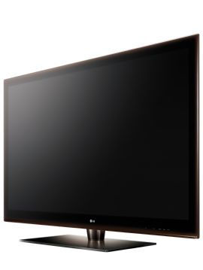

Code: TV0001

Name: LG 47’ Full HD LED TV

Color: Black

Screen size: 47 inches

Length: 1127mm

Width: 285mm(with stand)

Height: 762mm

Theme group: Modern, Cozy, Nature, Warm

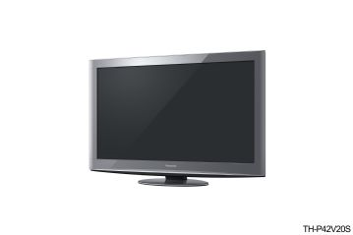

Code: TV0002

Name: PANASONIC 42’ Full HD PLASMA TV

Color: Silver

Screen size: 42inches

Length: 1080mm

Width: 320mm

Height: 682mm

Theme group: Modern, Cozy, Nature, Warm

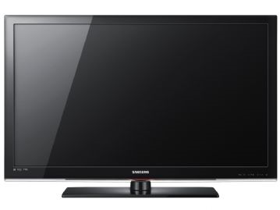

Code: TV0003

Name: SAMSUNG 32’ Full HD LCD TV

Color: Black

Screen size: 32inches

Length: 865mm

Width: 220 (without stand)

Height: 500mm

Theme group: Modern, Cozy, Nature, Warm

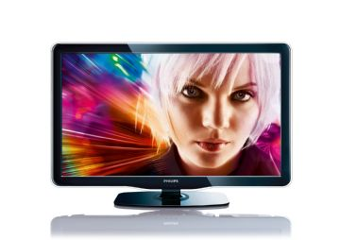

Code: TV0004

Name: PHILIPS 40’ Full HD LED TV

Color: Black

Screen size: 40inches

Length: 977mm

Width: 236mm(with stand)

Height: :649mm

Theme group: Modern, Cozy, Nature, Warm

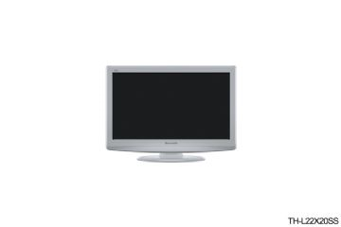

Code: TV0005

Name: PANASONIC 22’ LCD TV

Color: Silver

Screen size: 22inches

Length: 558mm

Width: 175mm

Height: 378mm

Theme group: Modern, Cozy, Nature, Warm

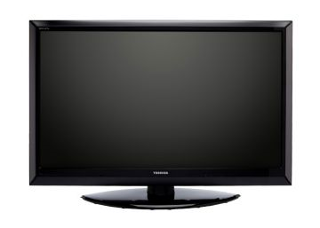

Code: TV0006

Name: TOSHIBA 55’ LED TV

Color: Black

Screen size: 55inches

Length: 1319mm

Width: 48mm

Height: 837

Theme group: Modern, Cozy, Nature, Warm

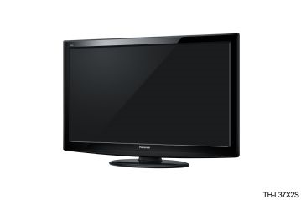

Code: TV0007

Name: PANASONIC 37’ LED TV

Color: Black

Screen size: 37inches

Length: 1041mm

Width: 381mm

Height: 632mm

Theme group: Modern, Cozy, Nature, Warm

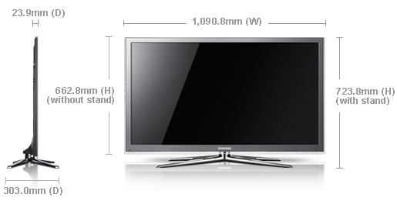

Code: TV0008

Name: SAMSUNG 46’ LED TV

Color: Silver

Screen size: 46inches

Length: 1091mm

Width: 303mm

Height: 723mm

Theme group: Modern, Cozy, Nature, Warm

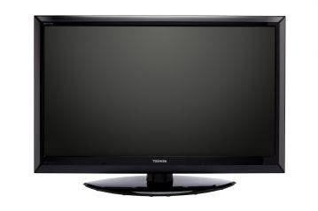

Code: TV0009

Name: TOSHIBA 47’ LED TV

Color: Black

Screen size: 47inches

Length: 1020mm

Width: 329mm

Height: 761mm

Theme group: Modern, Cozy, Nature, Warm

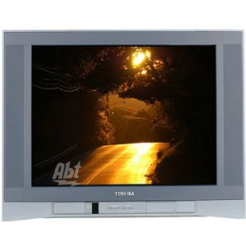

Code: TV0010

Name: TOSHIBA 24’ FLAT SCREEN TV

Color: Silver

Screen size: 24inches

Length: 762mm

Width: 610mm

Height: 680mm

Theme group: Cozy, Nature, Warm

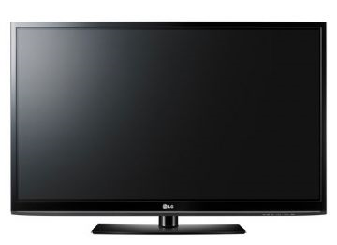

Code: TV0011

Name: LG 50’ PLASMA TV

Color: Black

Screen size: 50inches

Length: 1171mm

Width: 309mm

Height: 782mm

Theme group: Modern, Cozy, Nature, Warm

SOFA

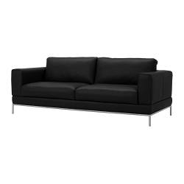

Code: SOFA0001

Name: ARILD Three-Seat Sofa

Color: Black

Length: 2070mm

Width: 940mm

Height: 810mm

Theme group: Modern, Cozy

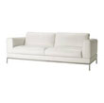

Code: SOFA0002

Name: ARILD Three-Seat Sofa

Color: White

Length: 2070mm

Width: 940mm

Height: 810mm

Theme group: Modern, Cozy, Nature

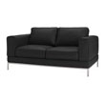

Code: SOFA0003

Name: ARILD Two-Seat Sofa

Color: Black

Length: 1560mm

Width: 940mm

Height: 810mm

Theme group: Modern, Cozy

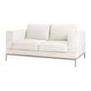

Code: SOFA0004

Name: ARILD Two-Seat Sofa

Color: White

Length: 1560mm

Width: 940mm

Height: 810mm

Theme group: Modern, Cozy, Nature

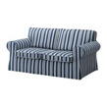

Code: SOFA0005

Name: EKTORP Two-seat sofa

Color: Blue & White Stripes

Length: 1385mm

Width: 740mm

Height: 800mm

Theme group: Cozy, Nature, Warm

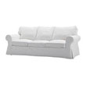

Code: SOFA0006

Name: EKTORP Three-seat sofa

Color: White

Length: 2590mm

Width: 770mm

Height: 730mm

Theme group: Modern, Cozy, Nature,warm

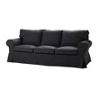

Code: SOFA0007

Name: EKTORP Three-seat sofa

Color: Black

Length: 2590mm

Width: 770mm

Height: 730mm

Theme group: Modern, Cozy

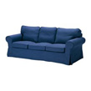

Code: SOFA0008

Name: EKTORP Three-seat sofa

Color: Blue

Length: 2590mm

Width: 770mm

Height: 730mm

Theme group: modern, Cozy, Nature

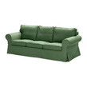

Code: SOFA0009

Name: EKTORP Three-seat sofa

Color: Green

Length: 2590mm

Width: 770mm

Height: 730mm

Theme group: Cozy, Nature

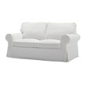

Code: SOFA0010

Name: EKTORP Two-seat sofa

Color: White

Length: 1080mm

Width: 770mm

Height: 730mm

Theme group: Modern, Cozy, Nature

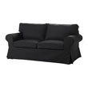

Code: SOFA0011

Name: EKTORP Two-seat sofa

Color: Black

Length: 1080mm

Width: 770mm

Height: 730mm

Theme group: Modern, Cozy

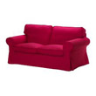

Code: SOFA0012

Name: EKTORP Two-seat sofa

Color: Red

Length: 1080mm

Width: 770mm

Height: 730mm

Theme group: Cozy, Warm

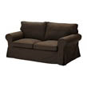

Code: SOFA0013

Name: EKTORP Two-seat sofa

Color: Dark-Brown

Length: 1080mm

Width: 770mm

Height: 730mm

Theme group: Cozy, Nature, Warm

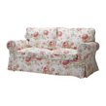

Code: SOFA0014

Name: EKTORP cover Two-seat sofa

Color: Flory

Length: 1080mm

Width: 770mm

Height: 730mm

Theme group: Cozy, Nature, Warm

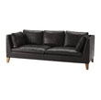

Code: SOFA0015

Name: IKEA STOCKHOLM Three-Seat sofa

Color: Black

Length: 2120mm

Width: 890mm

Height: 720mm

Theme group: Modern, Cozy

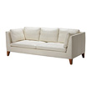

Code: SOFA0016

Name: IKEA STOCKHOLM Three-Seat sofa

Color: White

Length: 2120mm

Width: 890mm

Height: 720mm

Theme group: Modern, Cozy, Nature

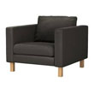

Code: SOFA0017

Name: KARLSTAD armchair

Color: Black

Length: 970mm

Width: 940mm

Height: 810mm

Theme group: Modern, Cozy

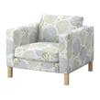

Code: SOFA0018

Name: KARLSTAD armchair

Color: Flory

Length: 970mm

Width: 940mm

Height: 810mm

Theme group: Cozy, Nature, Warm

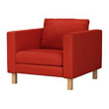

Code: SOFA0019

Name: KARLSTAD armchair

Color: Red

Length: 970mm

Width: 940mm

Height: 810mm

Theme group: Cozy, Warm

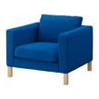

Code: SOFA0020

Name: KARLSTAD armchair

Color: Blue

Length: 970mm

Width: 940mm

Height: 810mm

Theme group: modern Cozy, Nature

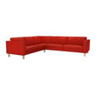

Code: SOFA0021

Name: KARLSTAD corner sofa 2+3/3+2

Color: Red

Length: 2800mm

Width: 930mm

Height: 800mm

Theme group: Cozy, Warm

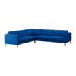

Code: SOFA0022

Name: KARLSTAD corner sofa 2+3/3+2

Color: Blue

Length: 2800mm

Width: 930mm

Height: 800mm

Theme group: Cozy, Nature

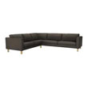

Code: SOFA0023

Name: KARLSTAD corner sofa 2+3/3+2

Color: Black

Length: 2800mm

Width: 930mm

Height: 800mm

Theme group: Modern, Cozy

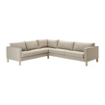

Code: SOFA0024

Name: KARLSTAD corner sofa 2+3/3+2

Color: Beige

Length: 2800mm

Width: 930mm

Height: 800mm

Theme group: Modern, Cozy, Nature, Warm

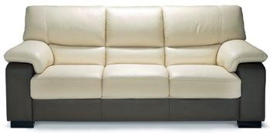

Code: SOFA0025

Name: ARMADIO CARONIA 3 Seaters sofa

Color: White

Length: 2060mm

Width: 940mm

Height: 930mm

Theme group: Cozy, Nature, Warm

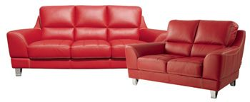

Code: SOFA0026

Name: ARMADIO SEVESCO 3 Seater sofa

Color: Red

Length: 2040mm

Width: 1000mm

Height: 880mm

Theme group: Cozy, Warm

Code: SOFA0027

Name: ARMADIO SEVESCO 2 Seater sofa

Color: Red

Length: 1560mm

Width: 1000mm

Height: 880mm

Theme group: Cozy, Warm

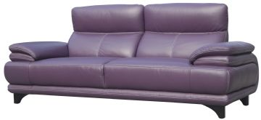

Code: SOFA0028

Name: ARMADIO LEON 3 Seater sofa

Color: Purple

Length: 2210mm

Width: 1030mm

Height: 910mm

Theme group: Modern, Cozy

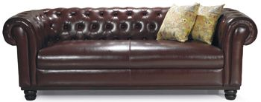

Code: SOFA0029

Name: DYNAMIC PICENO CHESTERFIELD 3 Seater sofa

Color: Dark Brown

Length: 2160mm

Width: 750mm

Height: 890mm

Theme group: Cozy, Nature, Warm

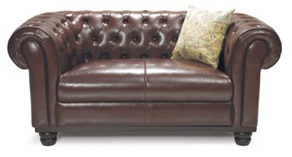

Code: SOFA0030

Name: DYNAMIC PICENO CHESTERFIELD 2 Seater sofa

Color: Dark Brown

Length: 1650mm

Width: 750mm

Height: 890mm

Theme group: Cozy, Nature, Warm

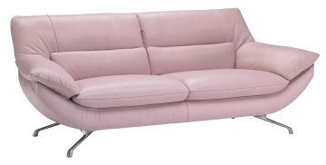

Code: SOFA0031

Name: ITALSOFA CROSIA 3 Seater sofa

Color: Pink

Length: 2240mm

Width: 950mm

Height: 850mm

Theme group: Cozy, Nature, Warm

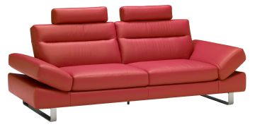

Code: SOFA0032

Name: ITALSOFA VEGA 3 Seater sofa

Color: Red

Length: 2250mm

Width: 950mm

Height: 950mm

Theme group: Cozy, Nature, Warm

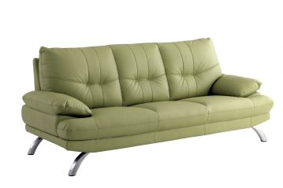

Code: SOFA0033

Name: LORENZO BRAXTON 3 Seater sofa

Color: Green

Length: 2240mm

Width: 950mm

Height: 800mm

Theme group: Cozy, Nature

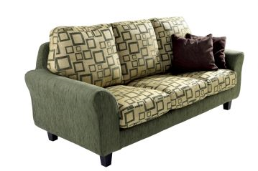

Code: SOFA0034

Name: DYNAMIC MARCEL 3 Seater sofa

Color: Green

Length: 2180mm

Width: 950mm

Height: 950mm

Theme group: Cozy, Nature

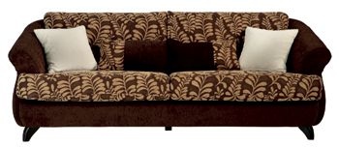

Code: SOFA0035

Name: DYNAMIC LUCIA 3 Seater sofa

Color: Brown

Length: 2130mm

Width: 820mm

Height: 860mm

Theme group: Cozy, Nature

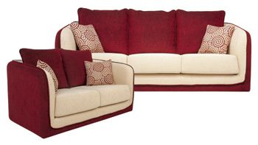

Code: SOFA0036

Name: DYNAMIC CARLA 3 Seater sofa

Color: Red

Length: 2130mm

Width: 960mm

Height: 910mm

Theme group: Cozy, Warm

Code: SOFA0037

Name: DYNAMIC CARLA 2 Seater sofa

Color: Red

Length: 1520mm

Width: 960mm

Height: 910mm

Theme group: Cozy, Warm

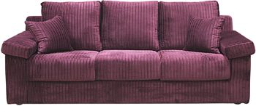

Code: SOFA0038

Name: KINGKOIL IP SWICH 3 Seater sofa

Color: Purple

Length: 2110mm

Width: 920mm

Height: 860mm

Theme group: Cozy

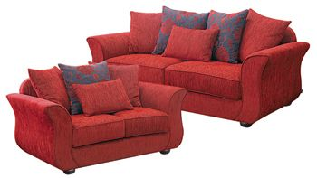

Code: SOFA0039

Name: KINGKOIL RENEE 3 Seater sofa

Color: Red

Length: 1980mm

Width: 940mm

Height: 910mm

Theme group: Cozy, Warm

Code: SOFA0040

Name: KINGKOIL RENEE 2 Seater sofa

Color: Red

Length: 1480mm

Width: 940mm

Height: 910mm

Theme group: Cozy, Warm

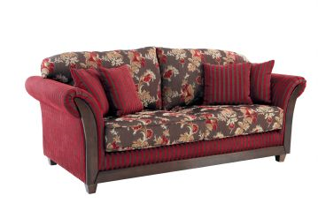

Code: SOFA0041

Name: STITCH ALLERGO 2 Seater sofa

Color: Flory

Length: 1390mm

Width: 890mm

Height: 870mm

Theme group: Cozy, Warm

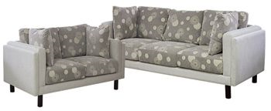

Code: SOFA0042

Name: SILENTNIGHT 3 Seater sofa

Color: Flory

Length: 1950mm

Width: 850mm

Height: 840mm

Theme group: Cozy, Nature

Code: SOFA0043

Name: SILENTNIGHT 2 Seater sofa

Color: Flory

Length: 1400mm

Width: 850mm

Height: 840mm

Theme group: Cozy, Nature

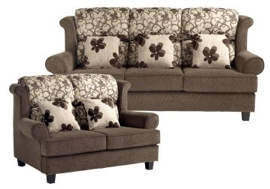

Code: SOFA0044

Name: DYNAMIC VINO 3 Seater sofa

Color: Flory

Length: 2200mm

Width: 850mm

Height: 840mm

Theme group: Cozy, Nature

Code: SOFA0045

Name: DYNAMIC VINO 2 Seater sofa

Color: Flory

Length: 1450mm

Width: 850mm

Height: 840mm

Theme group: Cozy, Nature

COFFEE TABLE

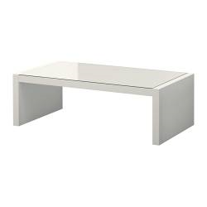

Code: CT0001

Name: EXPEDIT coffee table

Color: White

Length: 1180mm

Width: 590mm

Height: 380mm

Theme group: Modern, Cozy, Nature

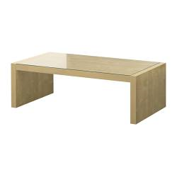

Code: CT0002

Name: EXPEDIT coffee table

Color: Brown

Length: 1180mm

Width: 590mm

Height: 380mm

Theme group: Cozy, Nature,warm

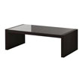

Code: CT0003

Name: EXPEDIT coffee table

Color: Black

Length: 1180mm

Width: 590mm

Height: 380mm

Theme group: Modern, Cozy

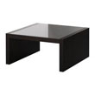

Code: CT0004

Name: EXPEDIT coffee table

Color: Black

Length: 780mm

Width: 780mm

Height: 380mm

Theme group: Cozy, Nature

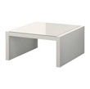

Code: CT0005

Name: EXPEDIT coffee table

Color: White

Length: 780mm

Width: 780mm

Height: 380mm

Theme group: Modern, Cozy, Nature

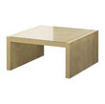

Code: CT0006

Name: EXPEDIT coffee table

Color: Brown

Length: 780mm

Width: 780mm

Height: 380mm

Theme group: Cozy, Nature, Warm

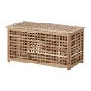

Code: CT0007

Name: HOL storage table

Color: Brown

Length: 980mm

Width: 500mm

Height: 500mm

Theme group: Cozy, Nature, Warm

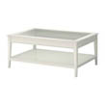

Code: CT0010

Name: LIATORP coffee table

Color: white

Length: 1180mm

Width: 780mm

Height: 500mm

Theme group: Modern, Cozy, Nature, Warm

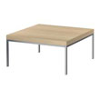

Code: CT0008

Name: KLUBBO coffee table

Color: Brown

Length: 780mm

Width: 780mm

Height: 370mm

Theme group: Cozy, Nature, Warm

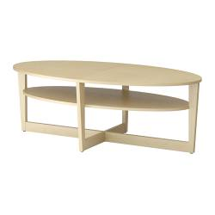

Code: CT0011

Name: VEJMON coffee table

Color: Brown

Length: 1400mm

Width: 660mm

Height: 470mm

Theme group: Cozy, Nature, Warm

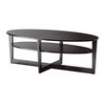

Code: CT0009

Name: VEJMON coffee table

Color: Black

Length: 1400mm

Width: 660mm

Height: 470mm

Theme group: Modern, Cozy

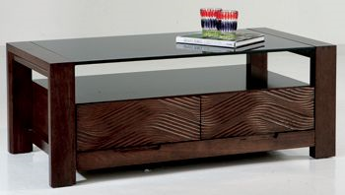

Code: CT0012

Name: BRADSHAW coffee table

Color: Dark Brown

Length: 1185mm

Width: 600mm

Height: 450mm

Theme group: Cozy, Nature, Warm

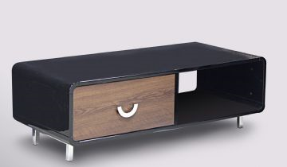

Code: CT0013

Name: SILENTNIGHT SOMERTON coffee table

Color: Black

Length: 1200mm

Width: 550mm

Height: 400mm

Theme group: Modern, Cozy, Nature, Warm

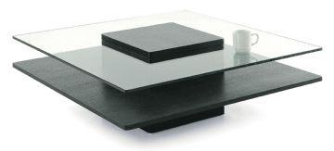

Code: CT0014

Name: GADINA coffee table

Color: White

Length: 1000mm

Width: 1000mm

Height: 350mm

Theme group: Modern, Cozy,warm

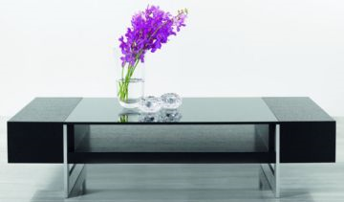

Code: CT0015

Name: ROCKALL coffee table

Color: Black

Length: 1200mm

Width: 700mm

Height: 330mm

Theme group: Modern, Cozy

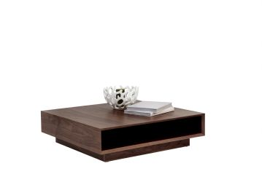

Code: CT0016

Name: AVOLA coffee table

Color: Brown

Length: 900mm

Width: 900mm

Height: 250mm

Theme group: Cozy, Nature, Warm

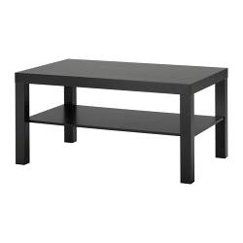

Code: CT0017

Name: LACK coffee table

Color: Black

Length: 900mm

Width: 550mm

Height: 450mm

Theme group: Modern, Cozy

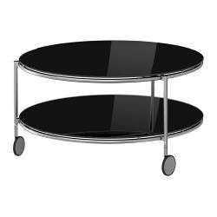

Code: CT0018

Name: STRIND coffee table

Color: Black

Diameter: 750mm

Height: 450mm

Theme group: Modern, Cozy

CUPBOARD

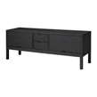

Code: CB0001

Name: IKEA STOCKHOLM TV BENCH

Color: Black

Length: 1650mm

Width: 1650mm

Height: 1000mm

Theme group: Modern, Cozy

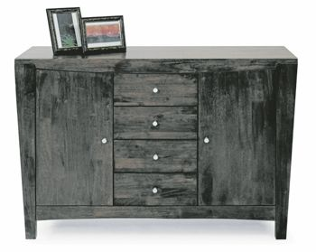

Code: CB0002

Name: BATON BUFFET

Color: Black

Length: 1200mm

Width: 420mm

Height: 830mm

Theme group: Cozy, Nature

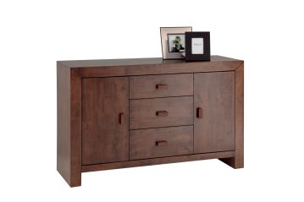

Code: CB0003

Name: NEW ASHBOURNE BUFFET UNITRICOLO OAK

Color: Brown

Length: 1150mm

Width: 440mm

Height: 830mm

Theme group: Cozy, Nature, Warm

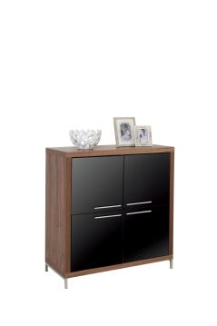

Code: CB0004

Name: VIZZINI DISPLAY CABINET

Color: Brown & BLACK

Length: 1070mm

Width: 480mm

Height: 1160mm

Theme group: Modern, Cozy, Nature, Warm

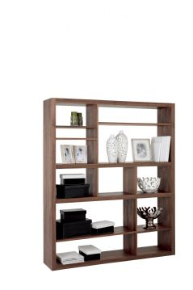

Code: CB0005

Name: AVOLA ROOM DIVIDER

Color: Brown

Length: 1530mm

Width: 320mm

Height: 1800mm

Theme group: Cozy, Nature, Warm

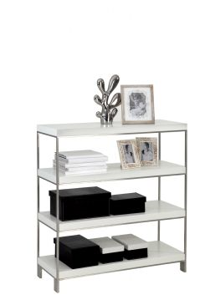

Code: CB0006

Name: CATANIA WALL DIVIDER

Color: White

Length: 1000mm

Width: 380mm

Height: 1090mm

Theme group: Modern, Cozy

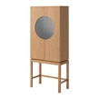

Code: CB0007

Name: IKEA STOCKHOLM glass-door cabinet

Color: Brown

Length: 1305mm

Width: 1305mm

Height: 1740mm

Theme group: Cozy, Nature, Warm

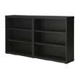

Code: CB0008

Name: BESTA wall shelf

Color: Black

Length: 1200mm

Width: 200mm

Height: 640mm

Theme group: Modern, Cozy

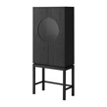

Code: CB0009

Name: IKEA STOCKHOLM glass-door cabinet

Color: Black

Length: 1305mm

Width: 1305mm

Height: 1740mm

Theme group: Modern, Cozy

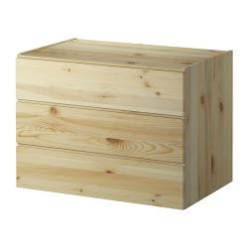

Code: CB0010

Name: IVAR chest of 3 drawers

Color: Brown

Length: 800mm

Width: 500mm

Height: 570mm

Theme group: Cozy, Nature, Warm

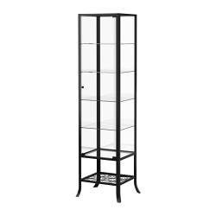

Code: CB0011

Name: KLINGSBO glass-door cabinet

Color: Black

Length: 450mm

Width: 400mm

Height: 1800mm

Theme group: Modern, Cozy

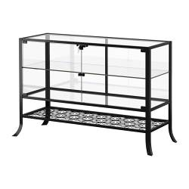

Code: CB0012

Name: KLINGSBO glass-door cabinet

Color: Black

Length: 1200mm

Width: 400mm

Height: 800mm

Theme group: Modern, Cozy

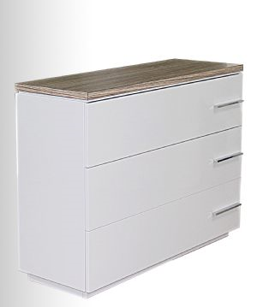

Code: CB0013

Name: SILENTNIGHT TALBOT CONSOLE TABLE

Color: White

Length: 1000mm

Width: 350mm

Height: 750mm

Theme group: Cozy, Nature, Warm

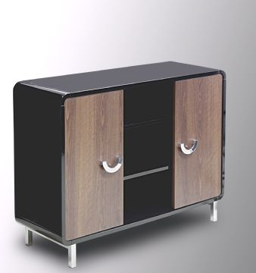

Code: CB0014

Name: SILENTNIGHT SOMERTON SIDEBOARD

Color: Black

Length: 1000mm

Width: 350mm

Height: 750mm

Theme group: Modern, Cozy, Nature, Warm

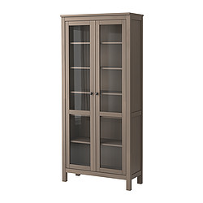

Code: CB0015

Name: HEMNES Glass-door cabinet

Color: Grey-Brown

Length: 900mm

Width: 370mm

Height: 1970mm

Theme group: Cozy, Nature, Warm

Media System

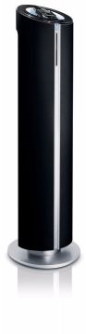

Code: MS0001

Name: PHILIPS DCM580 DOCKING ENTERTAINMENT SYSTEM

Color: Black

Length: 300mm

Width: 300mm

Height: 1022mm

Theme group: Modern, Cozy

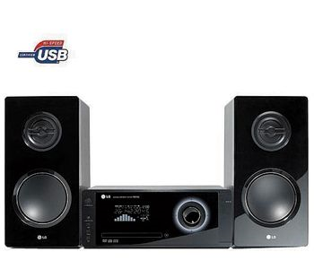b

Code: MS0002

Name: LG FBD103 DVD MICRO SYSTEM

Color: Black

Main

Length: 330mm

Width: 262mm

Height: 139mm

FrontSpeaker

Length: 164.5mm

Width: 220.5mm

Height: 341mm

Theme group: Modern, Cozy

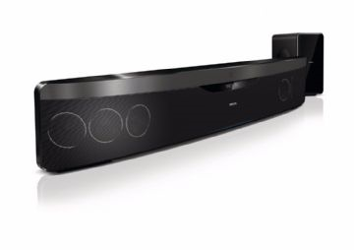

Code: MS0003

Name: **PHILIPS HTS7140 BLURAY SOUNDBAR**

Color: Black

Length: 1040mm

Width: 390mm

Height: 400mm

Theme group: Modern, Cozy

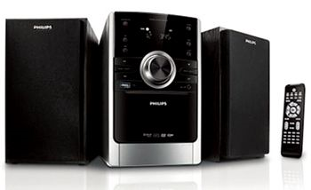

Code: MS0004

Name: **PHILIPS MCD170 DVD MICRO SYSTEM WITH USB**

Color: Black

Main

Length: 147mm

Width: 209mm

Height: 231mm

FrontSpeaker

Length: 134mm

Width: 153mm

Height: 233mm

Theme group: Modern, Cozy

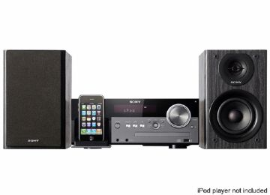

Code: MS0005

Name: S**ONY CMTMX500I CD MICRO SYSTEM w / IPOD DOCK**

Color: Black

Main

Length: 309mm

Width: 247mm

Height: 122mm

FrontSpeaker

Length: 150mm

Width: 220mm

Height: 240mm

Theme group: Modern, Cozy

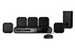

Code: MS0006

Name: **PHILIPS HTS2500 5.1 HOME THEATRE SYSTEM 4SA**

Color: Black

Main

Length: 360mm

Width: 331mm

Height: 57mm

FrontSpeaker

Length: 100mm

Width: 275mm

Height: 100mm

CentreSpeaker

Length: 100mm

Width: 275mm

Height: 100mm

Theme group: Modern, Cozy

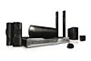

Code: MS0007

Name: **PHILIPS HTS7540 BLU RAY HOME THEATRE SYSTEM TB**

Color: Black

Main

Length: 435mm

Width: 358mm

Height: 58mm

SurroundSpeaker

Length: 262mm

Width: 264mm

Height: 1199mm

FrontSpeaker

Length: 100mm

Width: 280mm

Height: 115mm

CentreSpeaker

Length: 280mm

Width: 92mm

Height: 95mm

Subwoofer

Length: 196mm

Width: 342mm

Height: 395mm

Theme group: Modern, Cozy

Piano

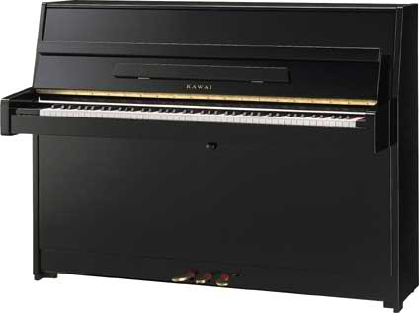

Code: PIANO0001

Name: KAWAI K15-E UPRIGHT PIANO

Color: BLACK

Length: 1490mm

Width: 590mm

Height: 1100mm

Theme group: Cozy, Warm

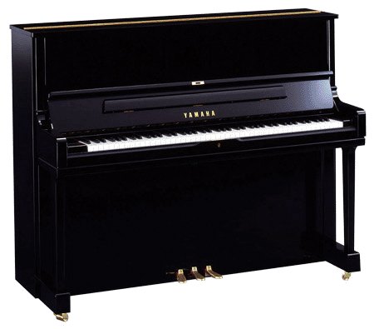

Code: PIANO0002

Name: YAMAHA YUS1 UPRIGHT PIANO

Color: BLACK

Length: 1520mm

Width: 610mm

Height: 1210mm

Theme group: Modern, Cozy, Warm

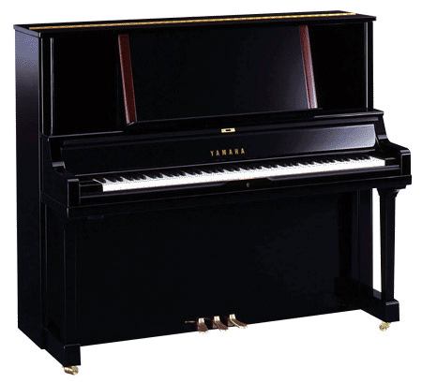

Code: PIANO0003

Name: YAMAHA YUS5 UPRIGHT PIANO

Color: BLACK

Length: 1520mm

Width: 650mm

Height: 1310mm

Theme group: Modern, Cozy, Warm

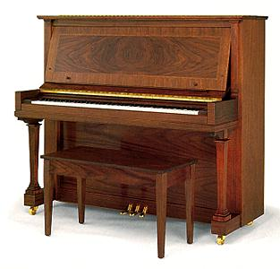

Code: PIANO0004

Name: YAMAHA U1 UPRIGHT PIANO

Color: Brown

Length: 1530mm

Width: 610mm

Height: 1210mm

Theme group: Cozy, Nature, Warm

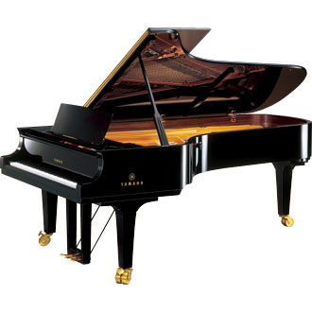

Code: PIANO0005

Name: YAMAHA CFX GRAND PIANO

Color: BLACK

Length: 1530mm

Width: 1530mm

Height: 1210mm

Theme group: Modern, Cozy, Nature, Warm

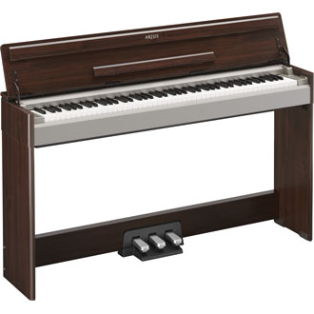

Code: PIANO0006

Name: YAMAHA YDP-S31 DIGITAL PIANO

Color: Dark Brown

Length: 1390mm

Width: 299mm

Height: 982mm

Theme group: Cozy, Nature, Warm

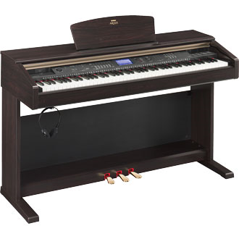

Code: PIANO0007

Name: YAMAHA YDP-V240 DIGITAL PIANO

Color: Dark Brown

Length: 1369mm

Width: 502mm

Height: 852mm

Theme group: Cozy, Nature, Warm

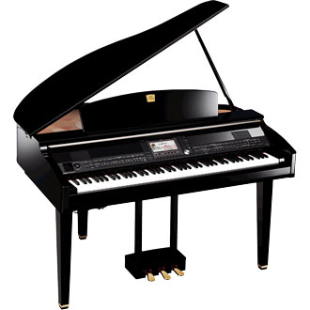

Code: PIANO0008

Name: YAMAHA CVP-409GP DIGITAL PIANO

Color: Black

Length: 1435mm

Width: 1147mm

Height: 905mm

Theme group: Modern, Cozy

Bookshelf

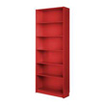

Code: BS0001

Name: BILLY Bookcase

Color: Red

Length: 800mm

Width: 280mm

Height: 2020mm

Theme group: Cozy, Warm

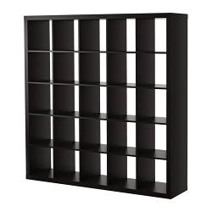

Code: BS0002

Name: EXPEDIT Bookcase

Color: Black

Length: 1850mm

Width: 390mm

Height: 1850mm

Theme group: Modern, Cozy, Nature

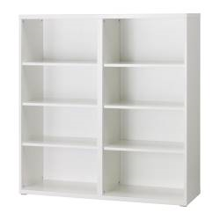

Code: BS0003

Name: BESTA shelf unit

Color: White

Length: 1200mm

Width: 400mm

Height: 1280mm

Theme group: Modern, Cozy

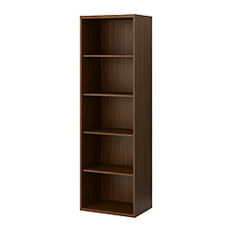

Code: BS0004

Name: BESTA shelf unit

Color: Brown

Length: 600mm

Width: 400mm

Height: 1920mm

Theme group: Cozy, Nature, Warm

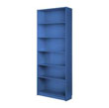

Code: BS0005

Name: BILLY Bookcase

Color: Blue

Length: 800mm

Width: 280mm

Height: 2020mm

Theme group: Cozy, Nature

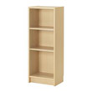

Code: BS0006

Name: BILLY Bookcase

Color: Beige

Length: 800mm

Width: 280mm

Height: 1020mm

Theme group: Cozy, Nature,Warm

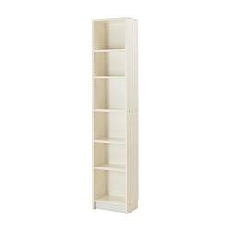

Code: BS0007

Name: BILLY Bookcase

Color: White

Length: 400mm

Width: 280mm

Height: 2202mm

Theme group: Modern, Cozy, Nature,Warm

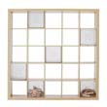

Code: BS0008

Name: EXPEDIT Bookcase

Color: White

Length: 1850mm

Width: 390mm

Height: 1850mm

Theme group: Modern, Cozy, Nature,Warm

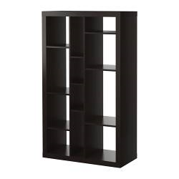

Code: BS0009

Name: EXPEDIT shelving unit

Color: Black

Length: 890mm

Width: 390mm

Height: 1490mm

Theme group: Modern, Cozy, Nature

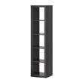

Code: BS0010

Name: EXPEDIT shelving unit

Color: Black

Length: 440mm

Width: 390mm

Height: 1850mm

Theme group: Modern, Cozy, Nature

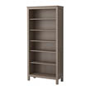

Code: BS0011

Name: HEMNES Bookcase

Color: Grey

Length: 900mm

Width: 370mm

Height: 1970mm

Theme group: Cozy, Nature, Warm

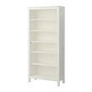

Code: BS0012

Name: HEMNES Bookcase

Color: White

Length: 900mm

Width: 370mm

Height: 1970mm

Theme group: Modern, Cozy

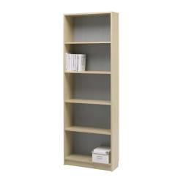

Code: BS0013

Name: KILBY Bookcase

Color: Beige

Length: 670mm

Width: 240mm

Height: 1940mm

Theme group: Cozy, Nature, Warm

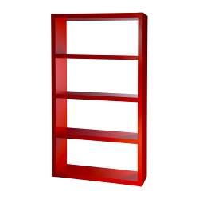

Code: BS0014

Name: LACK Bookcase

Color: Red

Length: 1050mm

Width: 380mm

Height: 1900mm

Theme group: Cozy, Nature, Warm

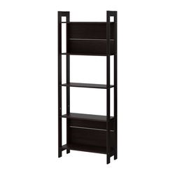

Code: BS0015

Name: LAVIA Bookcase

Color: Black

Length: 620mm

Width: 240mm

Height: 1650mm

Theme group: Modern, Cozy

Small Table

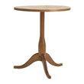

Code: ST0001

Name: DALOM pedestal table

Color: Brown

Diameter: 490mm

Theme group: cozy, Nature,

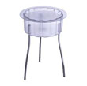

Code: ST0002

Name: HATTEN side table

Color: White

Diameter: 400mm

Theme group: Modern

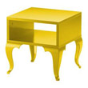

Code: ST0003

Name: TROLLSTA side table

Color: Yellow

Length: 380mm

Width: 380mm

Height: 400mm

Theme group: Cozy, Nature, Warm

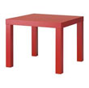

Code: ST0004

Name: LACK side table

Color: Red

Length: 550mm

Width: 550mm

Height: 450mm

Theme group: Cozy, Nature, Warm

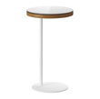

Code: ST0005

Name: IKEA STOCKHOLM side table

Color: White

Diameter: 360mm

Theme group: Modern, Cozy

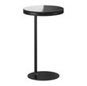

Code: ST0006

Name: IKEA STOCKHOLM side table

Color: Black

Diameter: 360mm

Theme group: Modern, Cozy

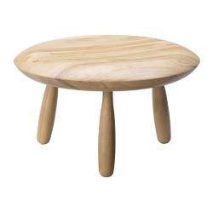

Code: ST0007

Name: IKEA PS KARLJOHAN side table

Color: Brown

Diameter: 470mm

Height: 270mm

Theme group: Cozy, Nature, Warm

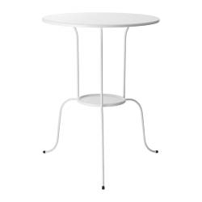

Code: ST0008

Name: LINDVED side table

Color: White

Diameter: 500mm

Theme group: Modern, Cozy

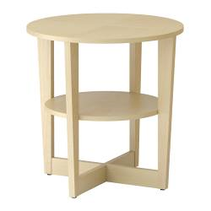

Code: ST0009

Name: VEJMON side table

Color: Beige

Diameter: 600mm

Theme group: Cozy, Nature, Warm

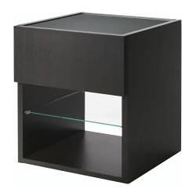

Code: ST0010

Name: RAMVIK side table with drawer

Color: Black-brown

Length: 430mm

Width: 450mm

Height: 500mm

Theme group: Modern, Cozy

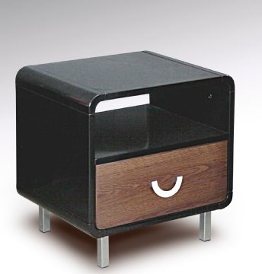

Code: ST0011

Name: SILENTNIGHT SOMERTON side table

Color: Black-brown

Length: 500mm

Width: 400mm

Height: 500mm

Theme group: Modern, Cozy, Nature, Warm

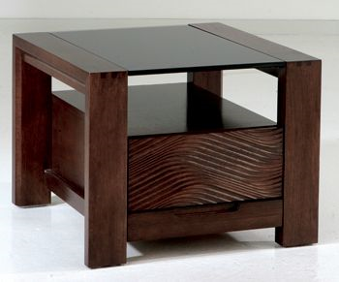

Code: ST0012

Name: BRADSHAW side table

Color: Brown

Length: 585mm

Width: 600mm

Height: 450mm

Theme group: Cozy, Nature, Warm

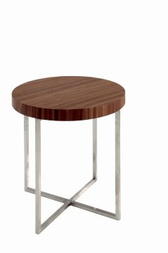

Code: ST0013

Name: GERACE side table

Color: Brown

Diameter: 450mm

Height:450mm

Theme group: Cozy

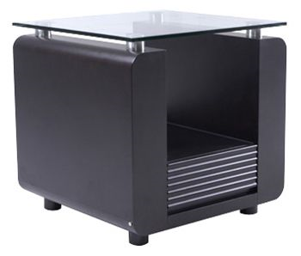

Code: ST0014

Name: LORENZO HAMPSHIRE side table

Color: Black

Length: 600mm

Width: 600mm

Height: 600mm

Theme group: Modern, Cozy, Nature

Table Lamp

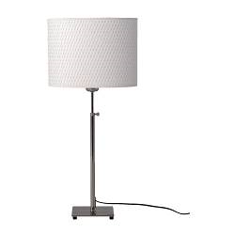

Code: TL0001

Name: ALANG Table Lamp

Color: White

Diameter: 270mm

Height:260mm

Theme group: Modern, Cozy, Nature,warm

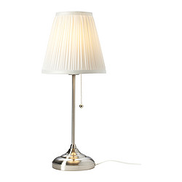

Code: TL0002

Name: ARSTID Table Lamp

Color: White

Diameter: 170mm

Height:170mm

Theme group: Modern, Cozy, Nature,warm

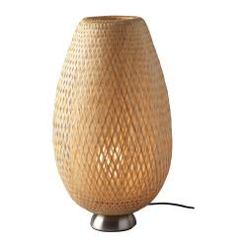

Code: TL0003

Name: BOJA Table Lamp

Color: Brown

Diameter: 200mm

Height: 400

Theme group: Cozy, Nature, Warm

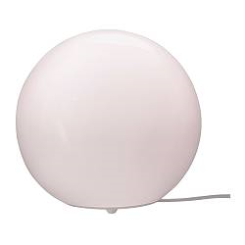

Code: TL0004

Name: FADO Table Lamp

Color: White

Diameter: 250mm

Height: 230mm

Theme group: Modern, Cozy

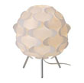

Code: TL0005

Name: FILLSTA Table Lamp

Color: White

Diameter: 270mm

Height:310mm

Theme group: Modern, Cozy,nature, warm

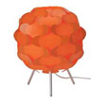

Code: TL0006

Name: FILLSTA Table Lamp

Color: Orange

Diameter: 270mm

Height: 310mm

Theme group: modern, Cozy, Nature, Warm

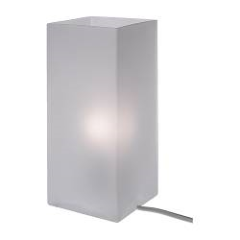

Code: TL0007

Name: GRONO Table Lamp

Color: White

Length: 100mm

Width: 100mm

Height:220mm

Theme group: Modern ,Cozy

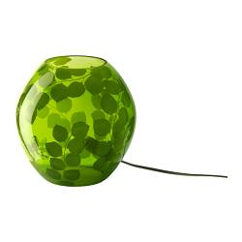

Code: TL0008

Name: KNUBBIG Table Lamp

Color: Green

Diameter: 200mm

Height: 110mm

Theme group: Cozy, Nature, Warm

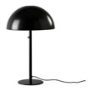

Code: TL0009

Name: IKEA 365+ BRASA Table Lamp

Color: Black

Diameter: 470mm

Height: 260mm

Theme group: Modern, Cozy

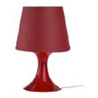

Code: TL0010

Name: LAMPAN Table Lamp

Color: Red

Diameter: 190mm

Height: 290mm

Theme group: Cozy, Nature, Warm

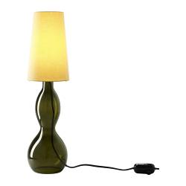

Code: TL0011

Name: LJUSAS SALBO Table Lamp

Color: Beige

Diameter: 140mm

Height: 610mm

Theme group: Cozy, Nature, Warm